**.SVG/.CDR files**

* The SVG/CDR file is a rectangle with 0.25 in. round edges. The rectangle is 3.4” wide by 0.187” tall. It was set to Hairline(i.e. 0.001). 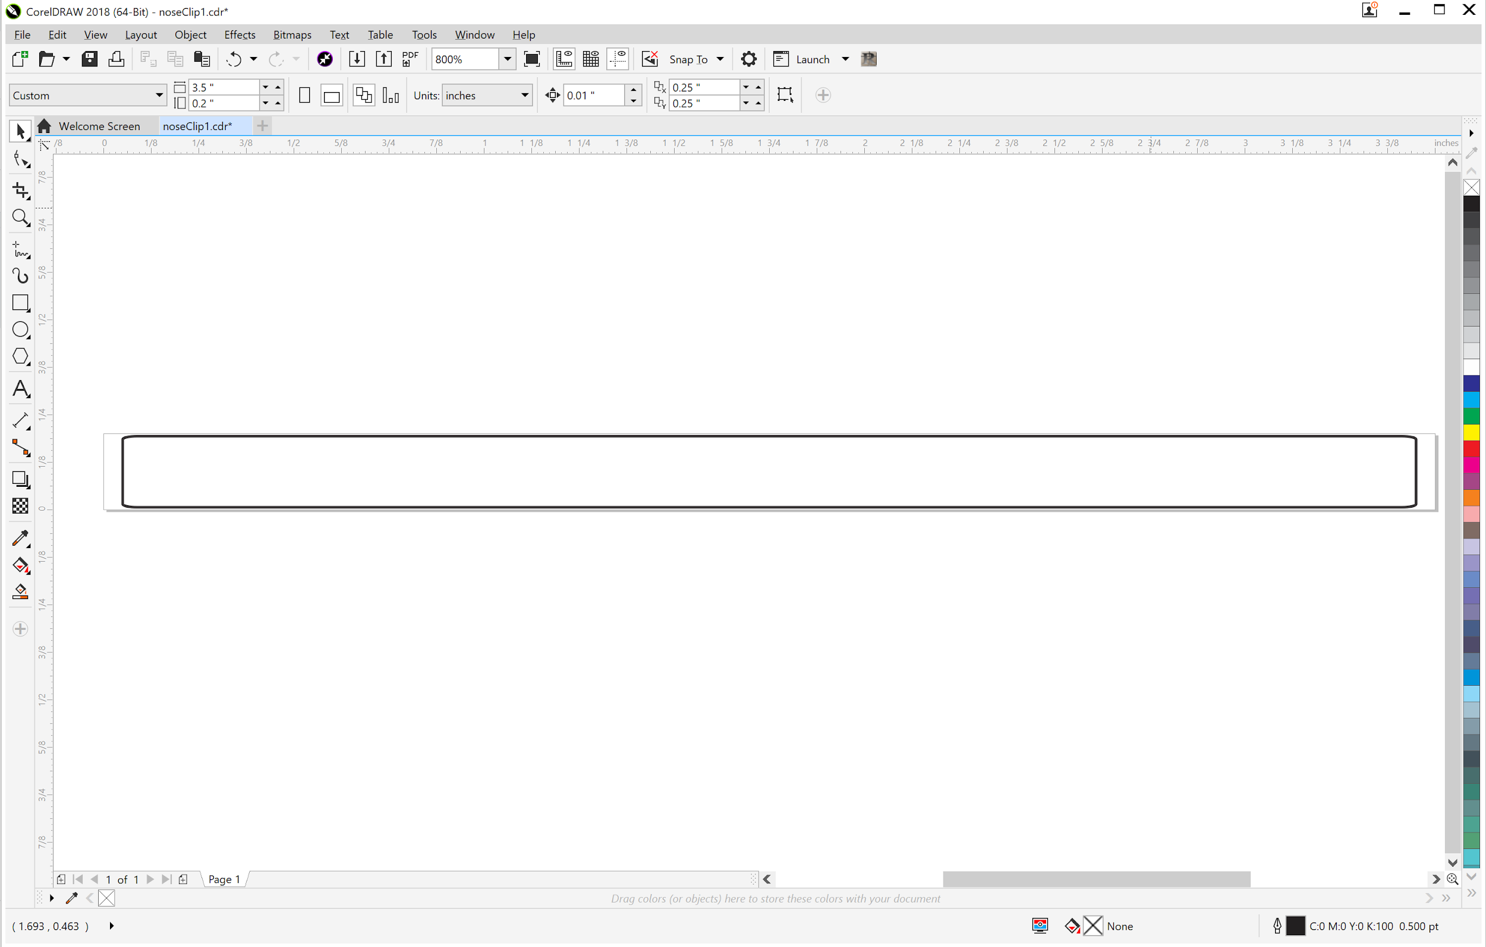
* The measurements were based on my N-95 mask’s metal clip> 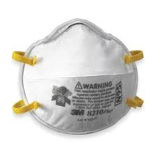The measurement for the metal clip on the N-95 is roughly 3.75 in. long by 0.187 wide by 0.465 in. thick
* I lightly sanded all the edge with high-grade (>220) sandpaper to remove any possible burrs
* [Aluminum Step Flashing](https://www.lowes.com/pd/Amerimax-3-in-x-7-in-Aluminum-Step-Flashing/3284366) was about 0.31mm and I cut it down to fit the mill (4”x4”) estimated sheet). Not sharp at all.
  + Photo examples: 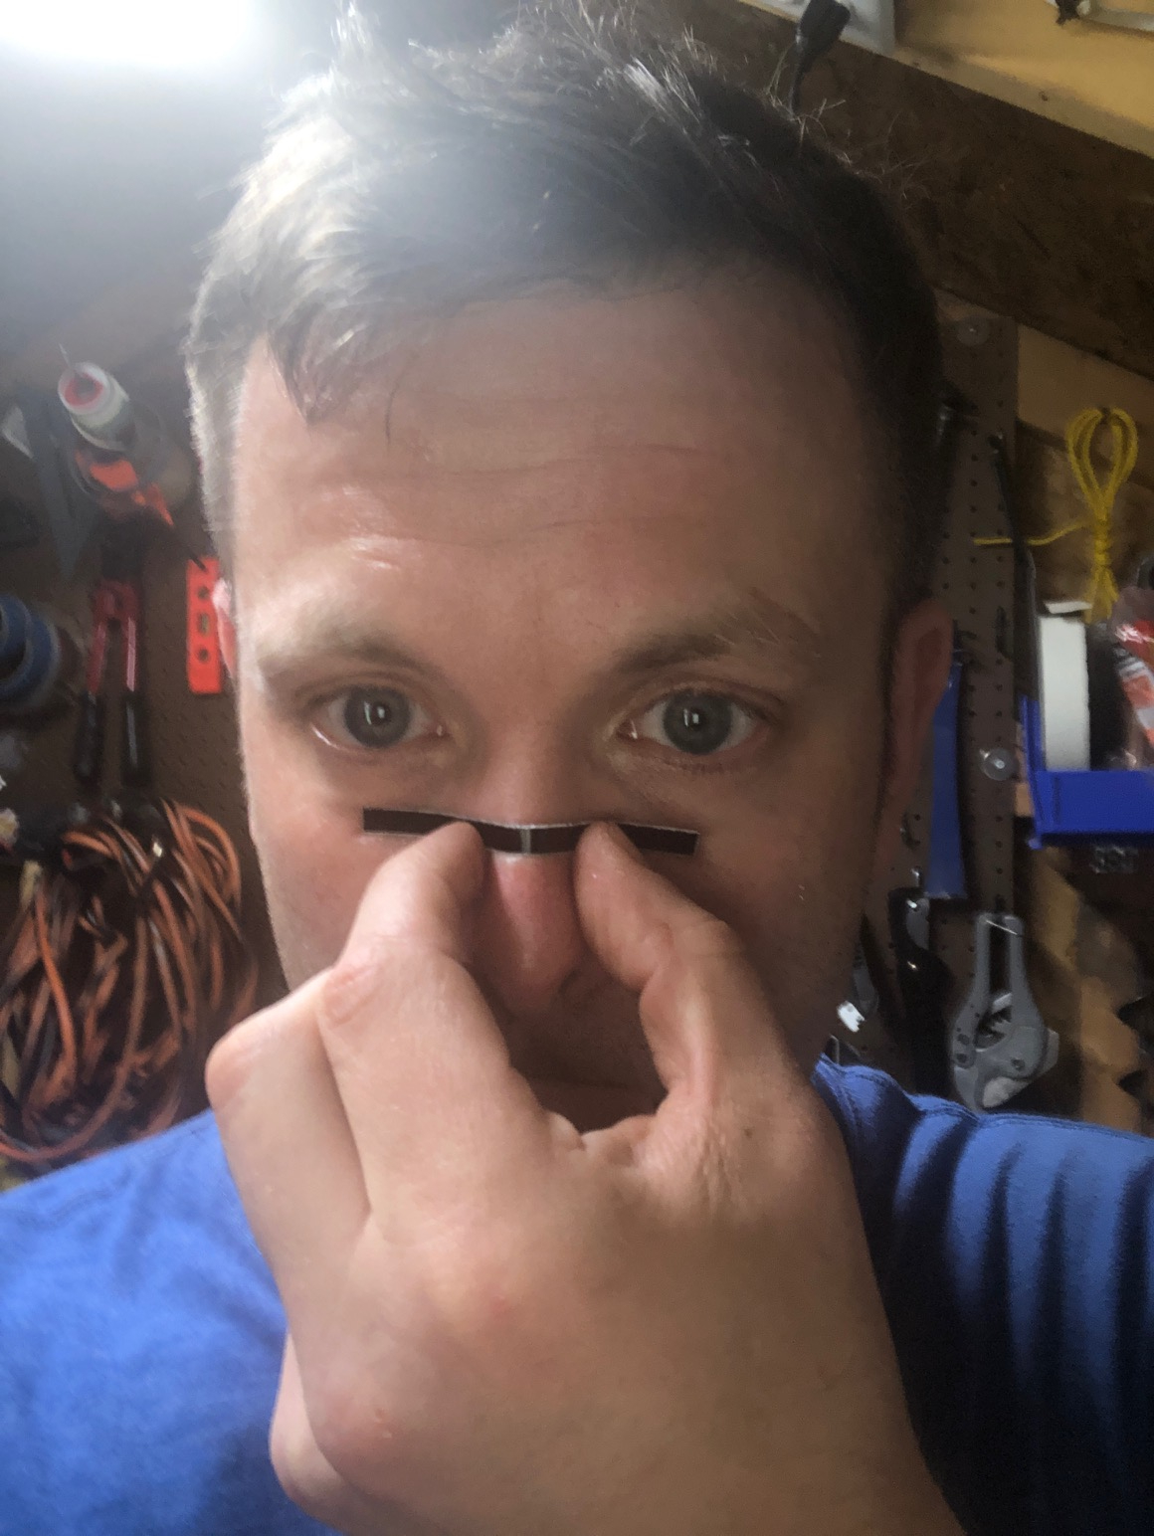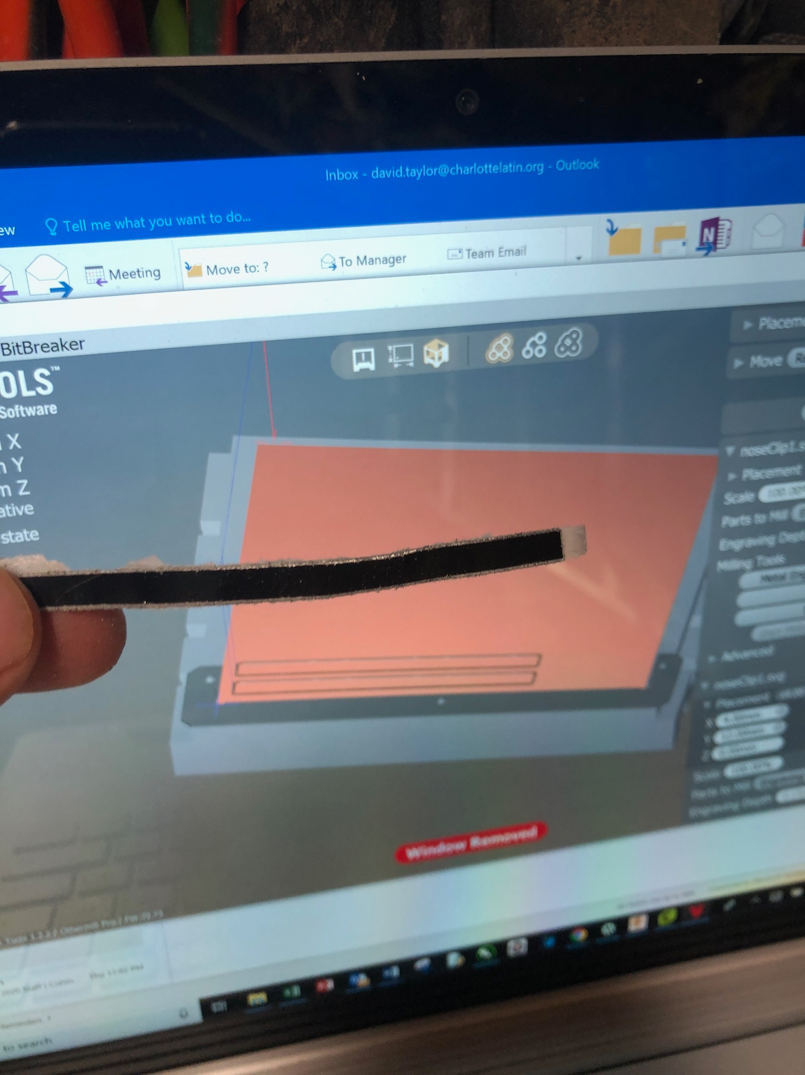
* The clips will need to be super-glued, epoxied, or hot glued to the masks.
* [Aluminum is from Bantam Tools](https://support.bantamtools.com/hc/en-us/articles/115001668413-Aluminum): The metal is 0.025” thick or about 0.89mm thick with tape as measured with my calipers. It needs more sanding compared to the previous version to get rid of burrs and possible sharp edges. It feels closer to the N-95 metal clip.
* This was milled out using an 80-degree metal engraving bit (⅛” bit) on the Bantam Tools mill